**Solution Architecture: Data & Control Flow**

● High-level system organization (all components of the system and the links among them)

The main components of the system will be the User Interface (Front End), the service layer and the Data layer. The front end will pass on commands by the means of HTTP requests/responses such as GET, POST etc. while the service layer will implement the required business logic in order to fetch/write data on to the database by the means of CRUD operations.

HTTP Request

User Interface

HTTP Response

Service Layer

CRUD OPERATIONS

Data Layer

● Flow of data through the system

From the user interface the users will be able to access/alter data in a database through a Rest API. The data will be passed on JSON format for simpler processing.

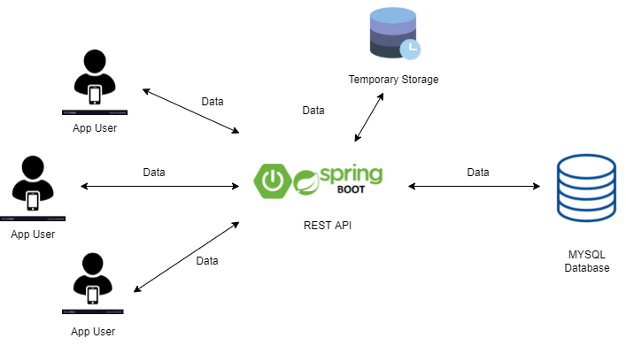

Once a student enters information about themselves and the grades, the service API will perform calculations such as calculating the GPA and so on. After that, the data will be stored in the database to be viewed by the student when necessary.

For showing the rank of a student the system will have to refer all records of a certain batch/field from the database and calculate the ranks which will be done by the Rest API which will then return the rank.

For showing the expected GPAs in future semesters the system will have to refer current GPA and courses from the database for the particular student, perform the necessary logic and return required grades.

● Storage of data at various points in the system (temporary and permanent)

The data will be mainly stored in MySql database.

● Flow of control through the system

Based on the different actions of the users’ end, events will be handled and the required messages will be sent for the Rest API which will then decide what should be done next.

MVC architecture will be the pattern of control flow in the app since this architecture provides the necessary clarity about data patterns as well as control.

